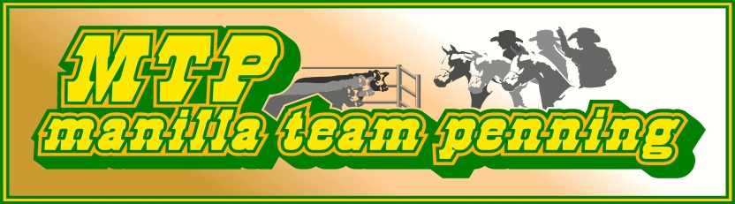
POSTAL ADDRESS:
The Secretary
P.O Box 163
Manilla NSW 2346
Website: www.manillateampenning.com
email manillatp@gmail.com

OFFICE USE ONLY DATE PAYMENT RECEIVED CASH/CHQ MEMBERSHP NO.

MEMBERSHIP APPLICATION & WAIVER FORM 2022
Valid 1st January, 2022 to 31st December, 2022
OPEN DIVISION: 18 YEARS AND OVER; YOUTH: 13 TO 17 YEARS; JUNIOR 12 YEARS AND UNDER

$75.00 FAMILY* $35.00 ADULT $20 YOUTH/JUNIOR** $15 DAY MEMBERSHIP
*Family Membership is defined as Spouse or Domestic Partner and/or dependent Child/Children under the age of 18 years.
**Once a competitor turns 13 or 18 years of age they are required to ride up in that division, at the next event after their birthday.
SURNAME………………………………………………………………FIRST NAME …………………………………………………………..
EMAIL ADDRESS (Please write neatly and be case specific)…………………………………………………………………………………….
POSTAL ADDRESS (Include your town & postcode) ………………………………………………...................................
……………………………………………………………………………………………………………………………………………………………….
TELEPHONE NO…………………………………………………………MOBILE NO………………………………………………………….
FAMILY, YOUTH AND JUNIOR MEMBERSHIP DETAILS
 | Name | DOB | Division
1
2
3
4
5

EMERGENCY CONTACT/NEXT OF KIN: Name and number………………………………………………………………………
Any Known Allergies/Medical Conditions that we should be aware of in case of accident/emergency
………………………………………………………………………………………………………………………………………………………………..
By checking this box I hereby authorise release of my personal contact information to be used by Manilla Team Penning for member contact lists and/or to other associations or organisations.
Upon acceptance of my/our membership, I/we agree to respect Manilla Team Penning Inc. committee’s decision and generally promote Manilla Team Penning in a positive manner. All riders 18 years and under must wear an appropriate safety helmet.

MEMBER ACKNOWLEDGEMENT 2013
HORSE RIDING AND PARTICIPATION IN HORSE RELATED ACTIVITY IS DANGEROUS

In consideration for being permitted to participate in any way in horse riding activities, I the undersigned, understand, acknowledge and accept that:
Horse riding and participation in horse related activities is/are dangerous recreational activities and horses and cattle can act in a sudden and unpredictable (changeable) ways, especially if frightened or hurt.
There is a significant risk that serious INJURY or DEATH may result from participating in horse related competition or activities.
I voluntarily PARTICIPATE at my OWN RISK and assume sole responsibility for any injury, death or property damage I may suffer that arises from my participation in horse related activities.
I understand and acknowledge the dangers associated with the consumption of alcohol or any mind altering drugs before and during the activity and I take full responsibility for any injury, loss or damage associated with their consumption. I agree not to drink alcohol or take drugs prohibited by law before or during any horse activity.
I agree to abide by the Rules and Regulations of Manilla Team Penning Inc., its affiliated clubs and/or management/organiser of the activities and that I will follow all directions of the management/organiser of the activities. My failure or refusal to do so can result in my immediate disqualification from the activities and the forfeiting of all fees paid in relation to the activities. I understand that any such non-compliance may result in injury, death and/or permanent disability.
I agree to wear a helmet of the currently approved Australian Standard in all activities where the Rules and Regulations governing the activity require the wearing of a helmet. I am solely responsible for ensuring that I wear a suitable helmet correctly when required and take sole responsibility for my actions.
I consent to receiving any medical treatment or injury assistance that Manilla Team Penning thinks desirable during or after my participation and will be responsible for any associated costs, however I do not require that special medical facilities or equipment be made available for me and I understand that treatment or assistance might not be immediately available when needed.
Animals are ridden by me at my risk. Manilla Team Penning Inc. is not responsible for injury, loss or damage resulting from animal behaviour (including behaviour caused by the presence of other animals or participants). In particular, Manilla Team Penning Inc. is not responsible for animal selection by or on behalf of participants (for example, an animal may be unsuitable for a participant by reason of the participant’s inexperience or age).
I consent to my animal/s receiving any medical treatment or injury assistance that Manilla Team Penning thinks desirable; when/if I am not available for consultation and will be responsible for any associated costs.
I understand that any insurance cover affected for participants may not cover me for any or all injury, loss or damage sustained by me.
I warrant that: All equipment provided or used by me in Manilla Team Penning activities is reasonably fit for its purpose – and any animal used by me in Manilla Team Penning activities is in good physical condition and is appropriate for my age, experience and anticipated riding activities.
Horse Experience – Not limited to riding: (tick where appropriate)
Very experience participant/competitor Novice participant/competitor Never participated/ competed
I confirm I am in good health and do not suffer from any disability which will affect my ability to participate. I have had sufficient opportunity to read this document, fully understand its terms and sign it freely and voluntarily without inducement of any kind.
NAME – PLEASE PRINT SIGN & DATE
-------------------------------------------------------------------- ------------------------------------------------------
-------------------------------------------------------------------- -------------------------------------------------------
-------------------------------------------------------------------- -------------------------------------------------------
-------------------------------------------------------------------- -------------------------------------------------------
PARENT OR GUARDIAN WHERE PARTICIPANT IS UNDER 18 YEARS OF AGE
NAME – PLEASE PRINT SIGN & DATE
--------------------------------------------------------------------- ------------------------------------------------------
------------------------------------------------------------------- ----------------------------------------------------------------------------------------------------------------------- ------------------------------------------------------

